

SEMINAR REPORT
A Seminar Report on
AI IN SOFTWARE TESTING
Submitted in partial fulfillment for the award of
THIRD YEAR DIPLOMA IN
COMPUTER ENGINEERING

Sr. No | Enrollment Number | Name of Student
1 | 24610960187 | Nikita Pravin Choudhari
2 | 24610960204 | Disha Badal Jugalkar
3 | 24610960219 | Mayuri Balkrushna Mali
4 | 24610960223 | Siddhi Vijay More

By
FOR THE ACADEMIC YEAR: 2026–2027
DEPARTMENT OF COMPUTER ENGINEERING
S.S.V.P.S's Bapusaheb Shivajirao Deore Polytechnic, Dhule
(Institute Code: 0059)

S.S.V.P.S's Bapusaheb Shivajirao Deore Polytechnic, Dhule
(An Affiliated Institute of Maharashtra State Board of Technical Education)
DEPARTMENT OF COMPUTER ENGINEERING
CERTIFICATE

Sr. No | Enrollment Number | Name of Student
1 | 24610960187 | Nikita Pravin Choudhari
2 | 24610960204 | Disha Badal Jugalkar
3 | 24610960219 | Mayuri Balkrushna Mali
4 | 24610960223 | Siddhi Vijay More

CO5K Semester of Diploma in Computer Engineering of S.S.V.P.S's B. S. Deore Polytechnic, Dhule (Institute Code: 0059), has completed the term work satisfactorily in Seminar Presentation and Project Initiation (Course Code: 315003) for the academic year 2026–2027 as prescribed in the curriculum.
Place: Dhule
Date: /10/2026

Signature: Signature:
Name: Name:
Subject Teacher Head of the Department

TABLE OF CONTENTS

Sr.No | Chapter | Page No.
 | Abstract | i
 | List of Figures | ii
 | List of Tables | iii
1. | Introduction | 1
2. | Literature Review | 2
3. | Information / Chapters | 3
4. | Advantages and Disadvantages | 8
5. | Conclusion | 9
6. | Project Initiation | 10
 | 6.1) Description of Problem Statement | 10
 | 6.2) Scope and Objectives | 10
 | 6.3) Stakeholders | 11
 | 6.4) Platform/ Equipment/ Resources identification | 12
7. | Seminar Presentation
 | Bibliography
 | Reference

ABSTRACT
Artificial Intelligence (AI) is becoming an important technology in software testing by improving the efficiency, accuracy, and reliability of software development processes. Traditional software testing methods often require considerable time, manual effort, and resources to identify software defects and ensure quality. With the advancement of AI technologies such as Machine Learning (ML), Natural Language Processing (NLP), and predictive analytics, software testing can be performed more intelligently and efficiently. AI-based testing tools help automate test case generation, test execution, defect prediction, test data generation, and test case prioritization.
This study focuses on the role of Artificial Intelligence in Software Process Improvement (SPI) and examines how AI can improve the overall software testing process. AI helps testers identify potential defects at an early stage, reduce repetitive manual tasks, improve test coverage, and accelerate the software testing life cycle. It can also analyze historical testing data, recognize patterns, and predict areas of software that are more likely to contain defects. These capabilities support better decision-making and help development teams maintain software quality while reducing testing time and effort.
The study also highlights the major benefits and challenges of implementing AI in software testing. Although AI offers advantages such as faster testing, improved accuracy, increased productivity, and continuous quality improvement, it also presents challenges related to implementation costs, data quality, tool complexity, and the need for skilled professionals. Furthermore, AI-generated test cases and predictions may require human verification to ensure reliable results.
In conclusion, Artificial Intelligence has significant potential to improve software testing practices and strengthen Software Process Improvement. The integration of AI-based testing tools with traditional testing techniques can help organizations develop high-quality, reliable, and efficient software. AI is not intended to completely replace human testers but to support them in performing complex testing activities and making better decisions. Therefore, the effective adoption of AI can contribute to continuous improvement in software quality and the overall software development process.

LIST OF FIGURES

Fig.No | Title | Page No.
1.1 | Application of Artificial Intelligence in Software Testing. | 4

LIST OF TABLES

Fig.No | Title | Page No.
2.1 | Literature Review | 2
3.1 | Evaluation Matrics | 12

CHAPTER 1

INTRODUCTION
Software testing is an essential activity in the software development life cycle (SDLC). It is the process of evaluating a software application to identify defects, errors, and failures and to verify whether the software meets the specified requirements. The main objective of software testing is to ensure that the software is reliable, secure, efficient, and user-friendly. Testing also helps improve software quality and increases customer satisfaction. Traditional software testing involves manual testing and automation testing. Manual testing requires testers to execute test cases, compare actual results with expected results, and report defects. Although manual testing is useful for identifying functional and usability issues, it can be time-consuming and repetitive. Automation testing uses tools and scripts to execute test cases automatically, but test scripts often require regular maintenance when software requirements or application interfaces change. Artificial Intelligence (AI) is a branch of computer science that enables machines and computer systems to perform tasks that normally require human intelligence. These tasks include learning from data, recognizing patterns, solving problems, making predictions, and supporting decision-making. AI uses various techniques, such as Machine Learning (ML), Natural Language Processing (NLP), deep learning, and predictive analytics, to process information and produce useful results.
AI is widely used in different fields, including healthcare, education, banking, transportation, cybersecurity, and software development. In software engineering, AI supports activities such as code analysis, debugging, requirement analysis, test generation, and defect prediction. By analyzing large amounts of software-related data, AI can help development teams identify problems more quickly and improve the overall development process.
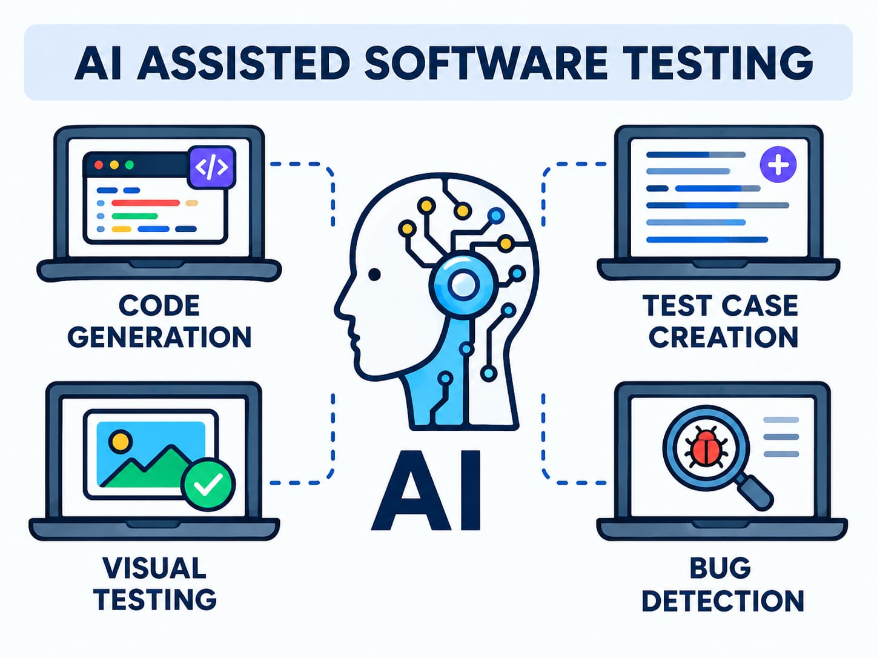
Figure 1: Application of Artificial Intelligence in Software Testing.

CHAPTER 2

LITERATURE REVIEW
A literature review is an important part of a research study that examines existing research papers, journal articles, and publications related to a particular topic. It helps understand the current state of knowledge, identify existing methods, compare research findings, and discover gaps that require further investigation. In recent years, Artificial Intelligence (AI) has gained significant attention in software testing because of its ability to automate testing activities and improve software quality. Researchers have explored different AI techniques, including Machine Learning (ML), Deep Learning, Natural Language Processing (NLP), and predictive analytics, to improve test case generation, defect prediction, test case prioritization, and test automation.

Review of Research Papers

1. Artificial Intelligence in Software Testing: A Systematic Review of a Decade of Evolution and Taxonomy (2025)
Authors: Alex Escalante-Viteri and David Mauricio.
Publication date: 14 November 2025.
This research paper presents a systematic review of AI techniques used in software testing between 2014 and 2024. The authors classify different testing problems and examine the AI algorithms used to address them. The study discusses how AI can support automated testing, defect prediction, and testing optimization. It also examines the input variables and performance metrics used in existing studies.
Research Gap: Different AI techniques use different evaluation metrics, making performance comparison difficult. More research is needed to standardize evaluation methods and test AI techniques on real-world projects.

2. A Systematic Review of Machine Learning Methods in Software Testing (2024)
Authors: Sedighe Ajorloo, Amirhossein Jamarani, Mehdi Kashfi, Mostafa Haghi Kashani, and Abbas Najafizadeh.
Publication: Applied Soft Computing, Volume 162, September 2024.
This study reviews 40 research papers published between 2018 and March 2024 on the use of Machine Learning in software testing. It examines supervised learning, unsupervised learning, reinforcement learning, and hybrid learning approaches. The authors compare the methods, advantages, disadvantages, and evaluation techniques used in existing studies.
Research Gap: Machine Learning models depend on high-quality training data. Further research is needed to improve accuracy when data is limited or imbalanced and when testing new software projects.

3. AI-Driven Software Testing: A Review (2026)
Authors: Guilherme Martins, Nelson Tenório, and Jorge Bernardino.
Publication date: 10 July 2026.
This review discusses the increasing use of AI to address the limitations of traditional software testing. It examines AI-driven approaches that can support automated testing and improve testing efficiency in increasingly complex software systems. The study considers how intelligent techniques can assist testing activities and identifies practical issues involved in adopting AI.
Research Gap: AI-driven testing faces challenges in validating generated test cases and handling complex software systems. More research is needed to improve reliability and practical implementation.

The Integration of Machine Learning into Automated Test Generation: A Systematic Mapping Study (2023)
Authors: Afonso Fontes and Gordon Fraser?
Publication: Software Testing, Verification and Reliability, Volume 33, Issue 4, Article e1845 (2023).
This research paper examines how Machine Learning (ML) techniques can be integrated into automated software test generation. The researchers conducted a systematic mapping study of 124 publications to understand the methods, objectives, evaluation approaches, and challenges associated with ML-based testing.
Research Gap: Machine Learning techniques show varying effectiveness across testing environments. Further research is needed to improve test coverage and generate more accurate and effective test cases.

Evaluating Large Language Models for Software Testing (2025)
Authors: Yihao Li, Pan Liu, Haiyang Wang, Jie Chu, and W. Eric Wong.
Publication: Computer Standards & Interfaces, Volume 93, Article 103942, April 2025.
This research evaluates Large Language Models (LLMs) for software testing tasks, including test-case generation, error tracing, and bug localization. The researchers examined these capabilities across 12 open-source projects. The study also investigates hallucinations, where an AI model produces incorrect or misleading information, and discusses ways to improve the reliability of AI-assisted testing.
Research gap: AI-generated test cases and bug reports still need reliable validation to ensure that they identify real software defects.

6. Harnessing Large Language Models for Automated Software Testing: A Leap Towards Scalable Test Case Generation (2025)
Authors: See the author list in the linked paper.
Publication: Electronics, Volume 14, Issue 7, Article 1463, 4 April 2025.
This study investigates the use of the Llama-2 language model to automatically generate unit tests for Java methods. It focuses on important methods within a program to generate more relevant test cases. The approach aims to reduce manual work and make test generation more scalable for software developers.
Research gap: Generated tests may not cover every execution path or detect all faults, so their effectiveness needs further evaluation across different programming languages and software projects.

7. Effective Test Generation Using Pre-trained Large Language Models and Mutation Testing (2024)
Publication: Information and Software Technology, Volume 171, Article 107468, July 2024.
This research introduces an approach called MuTAP, which combines prompts for Large Language Models with mutation testing. Mutation testing creates modified versions of a program to check whether test cases can detect the introduced faults. The study aims to improve the fault-detection ability of AI-generated tests rather than relying only on code coverage.
Research gap: Generating tests that achieve high code coverage does not always mean those tests can detect real defects. More reliable evaluation methods are needed.

8. Large Language Models for Software Testing: A Research Roadmap (2025)
Authors: Cristian Augusto, Antonia Bertolino, Guglielmo De Angelis, Francesca Lonetti, and Jesús Morán.
Publication date: 29 September 2025.
This paper presents a roadmap of how Large Language Models can be used in software testing. It organizes existing research into different categories, such as test-code generation, documentation analysis, and other testing activities. It also discusses current developments, limitations, and future opportunities for applying LLMs throughout the software testing lifecycle.
Research gap: Researchers need better methods to evaluate AI-generated tests and ensure their reliability, reproducibility, and usefulness in real-world projects.

Enhancing Search-Based Testing with LLMs for Finding Bugs in System Simulators (2025)
Publication: Automated Software Engineering, Volume 32, Article 63.
Publication date: 10 July 2025.
Authors: Aidan Dakhama, Karine Even-Mendoza, W. B. Langdon, Héctor D. Menéndez, Justyna Petke, and co-authors.
This study explores combining search-based software testing with Large Language Models to identify bugs in system simulators. Search-based testing explores different inputs to find program failures, while LLMs can help guide the search toward useful test inputs. The research investigates how these techniques can support more effective bug discovery.
Research gap: The approach needs further evaluation across different types of simulators and software systems to establish its general effectiveness.

Test Case Generation Using Large Language Models: A Systematic Literature Review (2026)
Authors: Murat Tasarsu, Ahmet Vedat Tokmak, and Cagatay Catal.
Publication: Cluster Computing, Volume 29, Article 227.
Publication date: 30 March 2026.
This systematic literature review examines how Large Language Models are being used to generate software test cases. It reviews existing research on automated test generation and considers how LLMs can reduce the time and effort required to create test cases. The paper also discusses the challenges involved in making AI-generated tests dependable and useful.
Research gap: Further research is needed to improve the correctness of generated tests, handle complex program logic, and establish consistent evaluation standards.

AI in GUI-Based Testing: A Survey of Techniques, Tools, and Perceived Advantages and Limitations (2026)
Publication: Journal of Systems and Software, Volume 235, Article 112751, May 2026.
Study method: Survey of 107 participants from academia and industry.
This research investigates how Artificial Intelligence is used to test graphical user interfaces (GUIs), including websites and software applications. It examines AI support for defining test cases, determining expected results, and optimizing tests. The study also explores the benefits and limitations perceived by people working in software testing.
Research gap: More empirical evidence is needed to determine how reliably AI-based GUI testing works across different interfaces and real-world applications.

How Well LLM-Based Test Generation Techniques Perform with Newer LLM Versions? (2026)
Authors: Michael Konstantinou, Renzo Degiovanni, and Mike Papadakis.
Conference: 19th IEEE International Conference on Software Testing, Verification and Validation (ICST 2026).
This research evaluates whether newer versions of Large Language Models improve automated unit-test generation. It investigates generating tests at the class level first and then targeting methods that remain uncovered. This strategy aims to improve testing effectiveness while reducing the number of requests made to the AI model. The researchers report comparable or slightly better effectiveness with approximately 20% fewer LLM requests.
Research gap: Further research is needed to determine how well these techniques perform across different programming languages, projects, and model versions.

- Research paper analysis and literature review chart
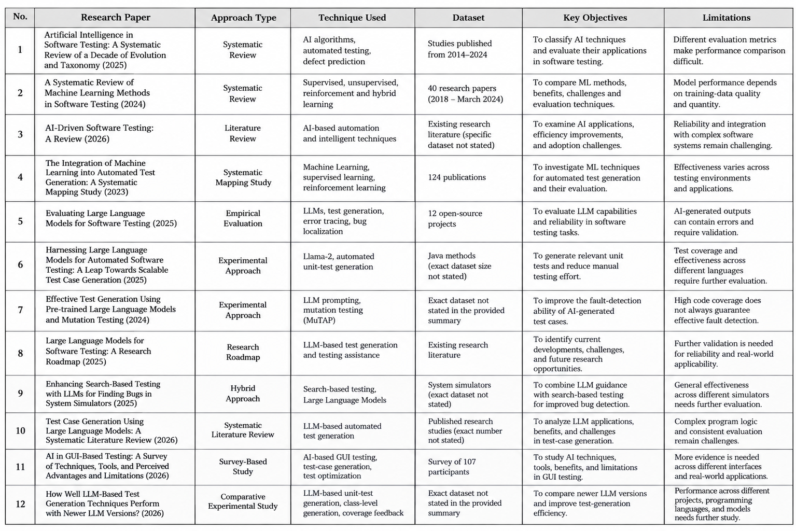

CHAPTER 3
INFORMATION / CHAPTER

3.1 Meaning of AI in Software Testing
Artificial Intelligence (AI) in software testing refers to the use of intelligent technologies to automate, improve, and optimize software testing activities. It uses techniques such as Machine Learning, Deep Learning, Natural Language Processing, and predictive analytics to analyze software requirements, generate test cases, identify defects, and improve testing efficiency. Traditional software testing mainly depends on manual testing and predefined automation scripts. These methods can require considerable time and effort, especially when software applications are frequently updated. AI-based testing can analyze historical test results, source code, application behavior, and defect reports to support testing decisions and automate repetitive activities.

3.2 Common AI Techniques

1. Machine Learning (ML)

2. Deep Learning (DL)

3. Natural Language Processing (NLP)

4. Reinforcement Learning (RL)

5. Predictive Analytics

6. Generative AI

3.3 Applications of AI in Software Testing

1. Automated Test Case Generation

2. Defect Prediction

3. Test Case Prioritization

4. Test Automation and Maintenance

5. Visual Testing

6. Test Data Generation

7. Log Analysis and Failure Diagnosis

8. Regression Testing

3.4 Typical Workflow of AI in Software Testing

Step 1: Requirement Collection

Step 2: Data Collection

Step 3: Data Preparation and Analysis

Step 4: AI Model or Tool Selection

Step 5: Test Case Generation and Prioritization

Step 6: Test Execution

Step 7: Defect Detection and Analysis

3.5 Evaluation Metrics
These metrics help organizations assess the performance of AI-based testing tools and identify areas requiring improvement. No single metric is sufficient to evaluate the complete testing process. Therefore, a combination of coverage, detection performance, testing time, automation, and cost metrics should be considered when evaluating AI-based software testing.
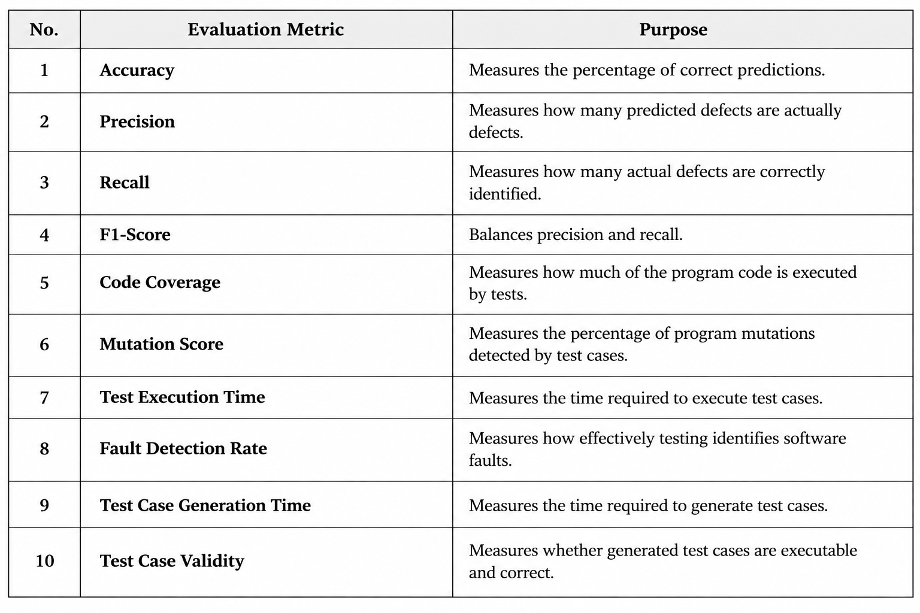

CHAPTER 4

ADVANTAGES AND DISADVANTAGES

Advantages
• AI helps automate repetitive software testing tasks and saves time.
• AI can improve test coverage by generating additional test cases.
• AI helps detect potential software defects at an early stage.
• AI supports test case prioritization based on risk and code changes.
• AI can reduce manual effort and improve testing efficiency.
• AI helps analyze testing data and identify patterns in defects.
• AI supports continuous testing and software process improvement.
• AI can reduce testing time and operational costs over time.

Disadvantages
• Results depend on the quality and representativeness of available data.
• AI may produce incorrect, incomplete, or irrelevant test cases.
• Tools may require setup, integration, training, and ongoing maintenance.
• Predictions can be difficult to explain and may reproduce bias in historical data.
• Sensitive source code, test data, or customer information may create privacy and security risks.
• Human review and conventional testing remain necessary.
• Initial implementation costs may be high for small organizations.
• AI may fail to identify complex defects that require human judgment.

CHAPTER 5

CONCLUSION
Artificial Intelligence (AI) is becoming an important technology in software testing and Software Process Improvement (SPI). It helps improve the efficiency, accuracy, and reliability of software testing by automating repetitive activities and supporting intelligent decision-making. AI techniques such as Machine Learning, Deep Learning, Natural Language Processing, and Generative AI can assist in test case generation, defect prediction, test case prioritization, test data generation, and automated test execution.
The study highlights that AI-based testing can reduce manual effort, save testing time, improve test coverage, and help identify potential defects at an early stage. It can also analyze historical testing data and recognize patterns that help software development teams identify high-risk areas. These capabilities support continuous testing and contribute to improvements in software quality and development productivity.
However, the implementation of AI in software testing also presents certain challenges. The effectiveness of AI depends on the quality of available data, the reliability of the tools, and the skills of the professionals using them. High implementation costs, maintenance requirements, privacy concerns, and incorrect predictions can also affect the testing process. Therefore, AI-generated test cases and results should be properly reviewed and validated by human testers.
In conclusion, Artificial Intelligence has significant potential to transform traditional software testing into a more intelligent, automated, and data-driven process. The combination of AI-based tools, conventional testing techniques, and human expertise can help organizations develop reliable, secure, and high-quality software. With continuous research, suitable evaluation methods, and responsible implementation, AI can contribute significantly to Software Process Improvement and the future advancement of software testing.

CHAPTER 6

PROJECT INITIATION

6.1 Description of Problem Statement
Traditional software testing often requires considerable manual effort, time, and resources to identify defects and verify software functionality. Preparing test cases, executing repetitive tests, maintaining automation scripts, and analyzing testing results can become challenging as software applications grow in complexity.
Traditional automation testing follows predefined scripts and may require frequent updates when application requirements or interfaces change. In addition, limited testing time can make it difficult to cover all possible scenarios and identify every defect.
Therefore, there is a need to explore intelligent testing approaches that can automate repetitive activities, improve test case selection, and support early defect detection. Artificial Intelligence can help address these challenges by analyzing software data, generating test cases, prioritizing tests, and identifying potential problem areas.

6.2 Scope and Objectives

Scope
- Develop a small demonstration using sample or synthetic test-history data.
- Compare a basic rule-based ranking with a simple machine-learning approach, if suitable labelled data is available.
- Display a ranked list of test cases and explain the factors used.
- Evaluate the approach using clearly stated measures.
- Keep the prototype limited to educational demonstration; it will not replace a full testing framework.

Objectives
- To understand the concept of AI in software testing.
- To study common AI techniques used in software testing.
- To identify the applications of AI in test automation and defect detection.
- To examine the advantages and disadvantages of AI-based testing.
- To understand evaluation metrics used to measure testing effectiveness.
- To study the challenges associated with implementing AI in software testing.
- To analyze how AI contributes to Software Process Improvement.
- To identify research gaps and possible future developments in AI-based testing.

6.3 Stakeholders
- Project Guide: Provides guidance, monitors progress, and reviews the project work.
- Students / Researchers: Collect information, study research papers, and prepare the report.
- Software Testers: Use testing techniques and AI-based tools to identify software defects.
- Software Developers: Use testing results to correct defects and improve software quality.
- Project Managers: Monitor project progress, testing costs, and software quality.
- Organizations: Adopt AI-based testing approaches to improve productivity and testing efficiency.
- End Users: Benefit from reliable, secure, and high-quality software applications.

6.5 Platform / Equipment / Resources Identification

Hardware Resources
- Laptop or desktop computer for research and report preparation.
- Internet connection for accessing online research materials.
- Projector and presentation equipment for the seminar.

Software and Online Platforms
- Google Scholar: To find research papers related to AI in software testing.
- IEEE Xplore: To access research publications on software engineering and AI.
- ScienceDirect: To study journal articles related to AI and software testing.
- Microsoft Word / Google Docs: To prepare and format the project report.
- Microsoft PowerPoint / Google Slides: To create the seminar presentation.

Learning Resources
- Research papers and journal articles.
- Software testing textbooks and reference materials.
- Official documentation of AI and automation testing tools.
- Online tutorials, technical articles, and case studies.
- Guidance from the project supervisor and faculty members.

CHAPTER 7

SEMINAR PRESENTATION
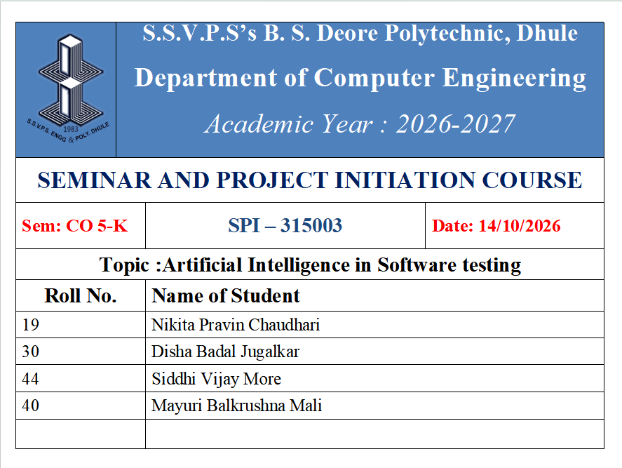
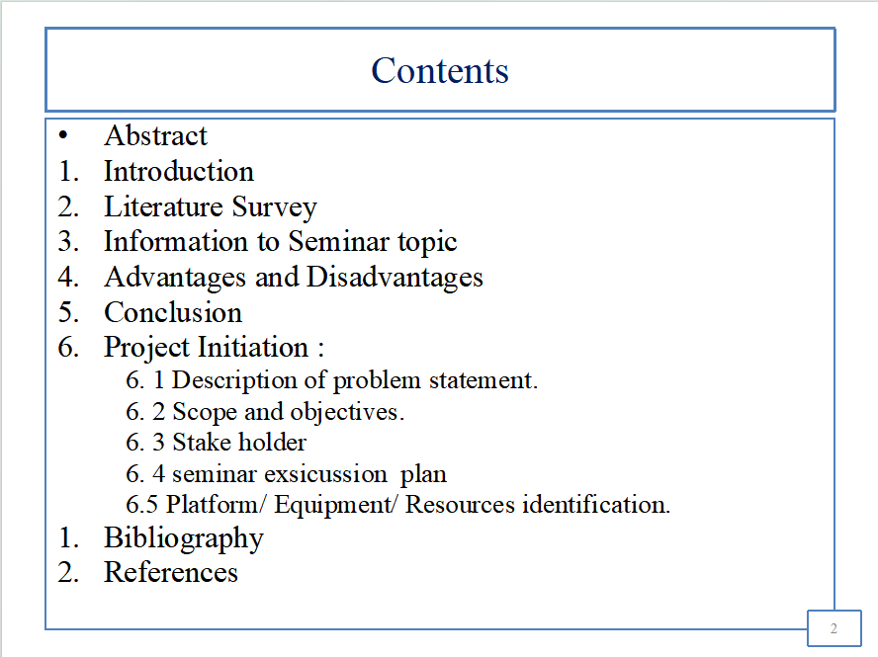

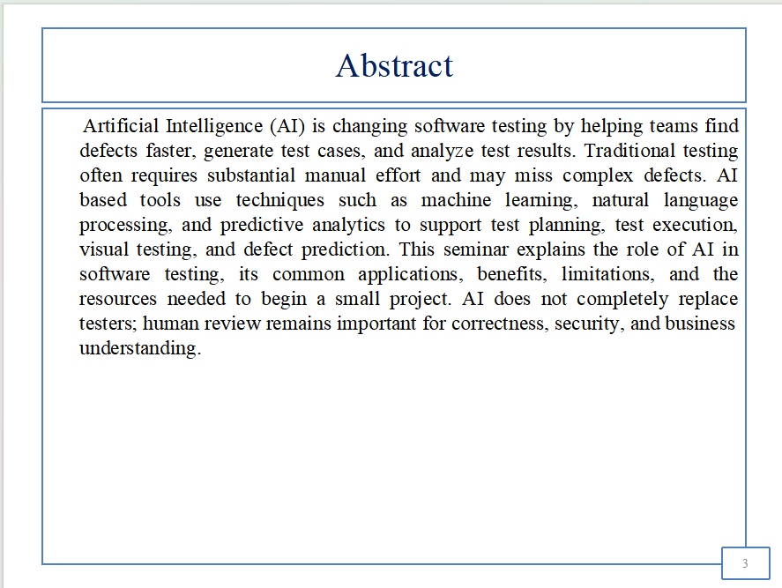
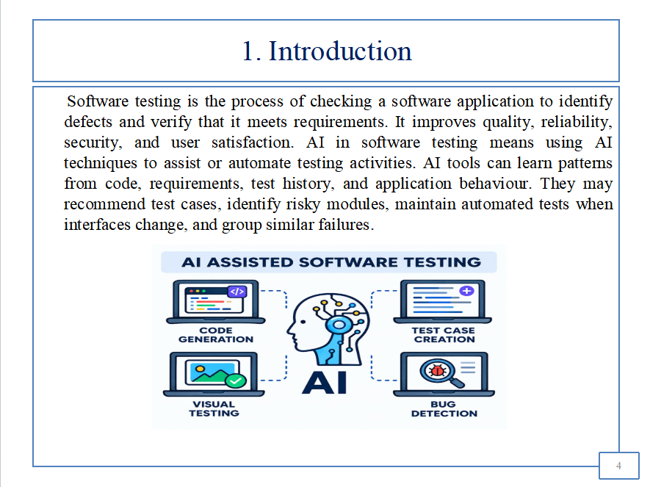

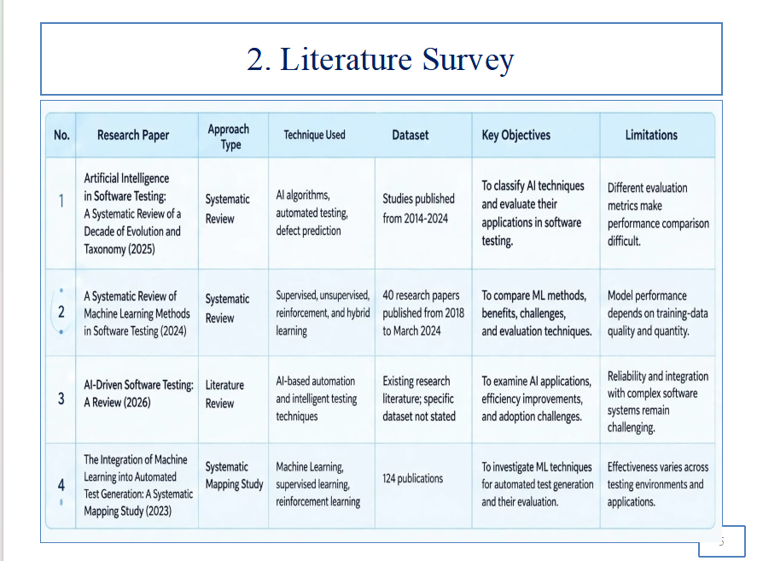
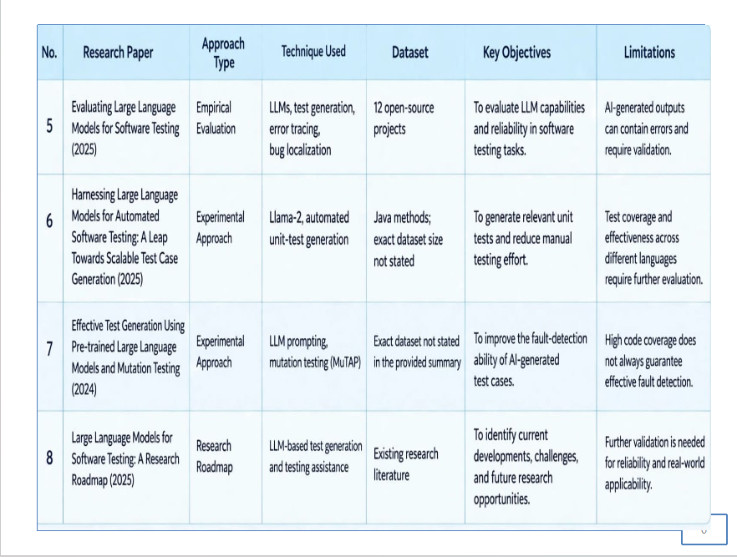

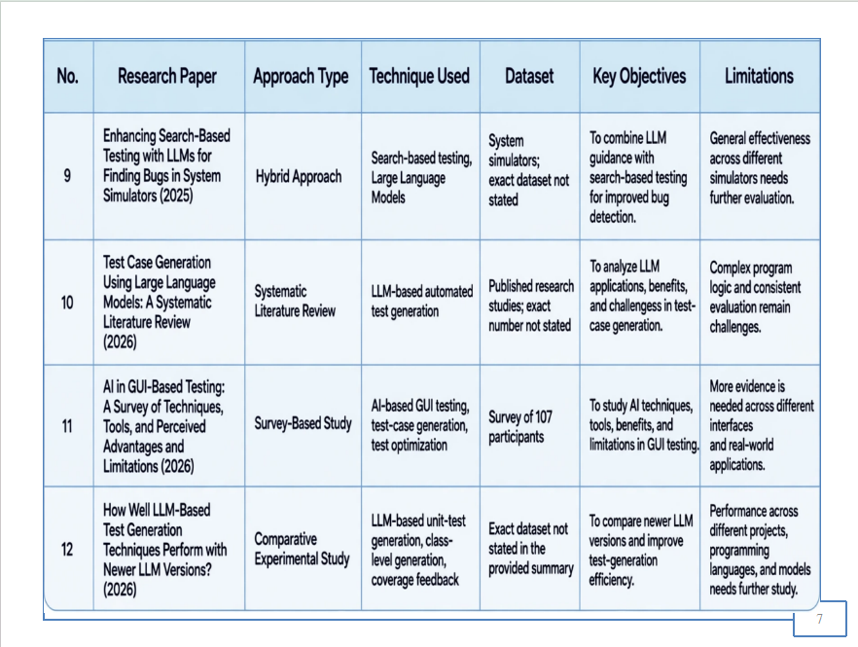
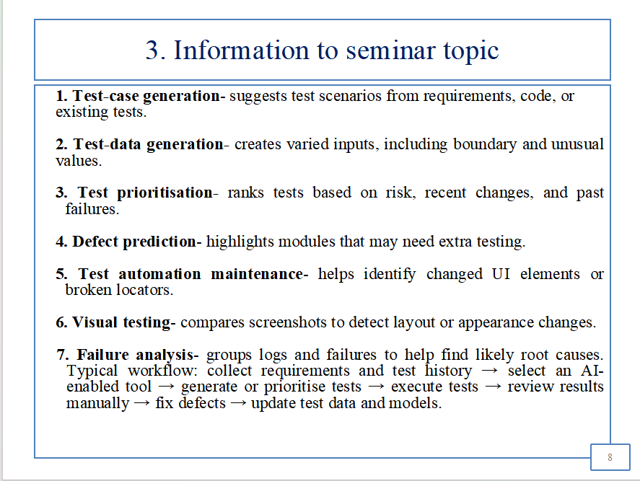

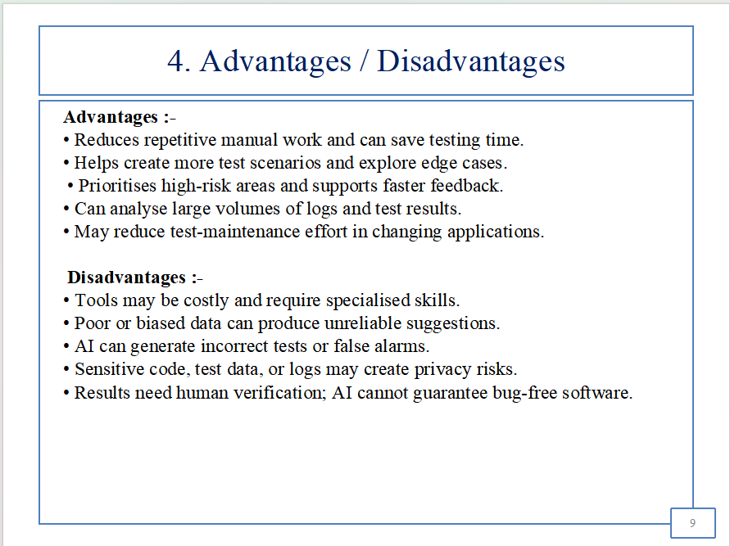
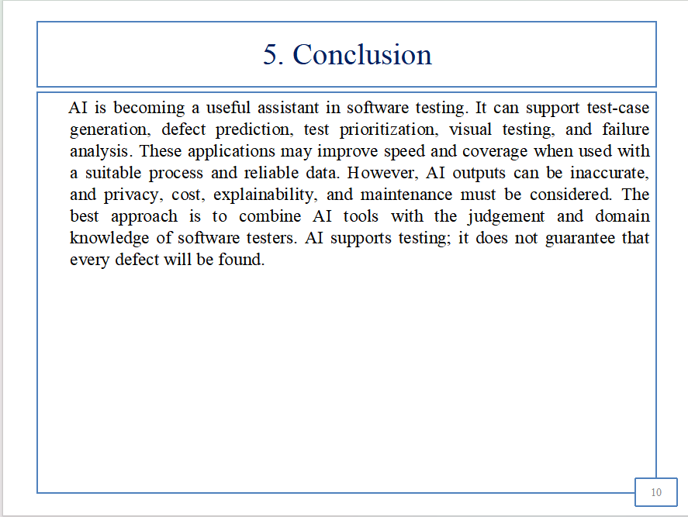

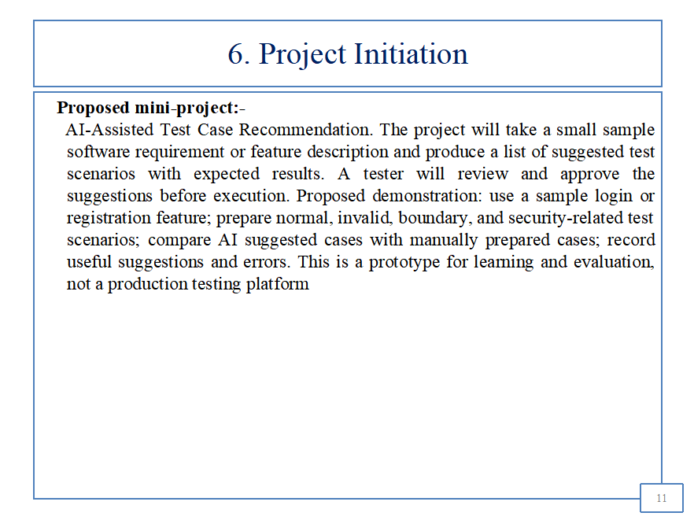
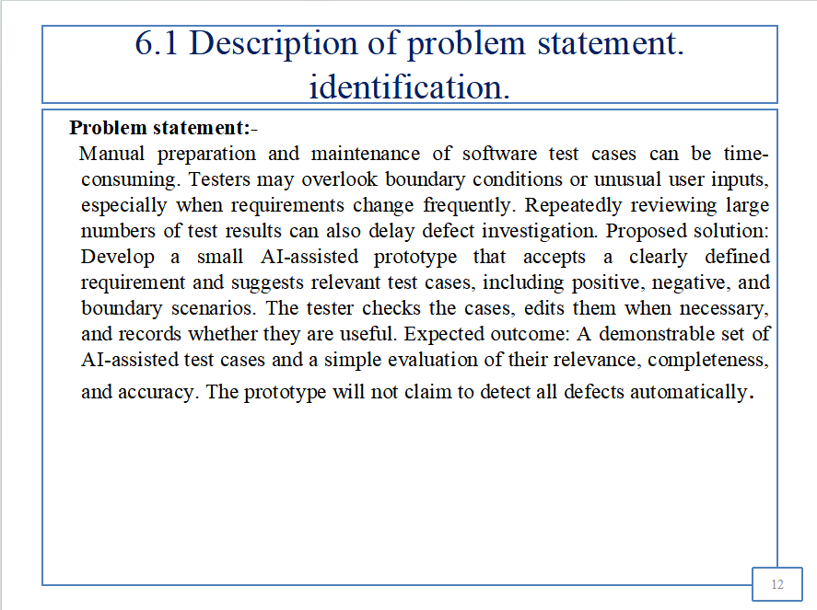

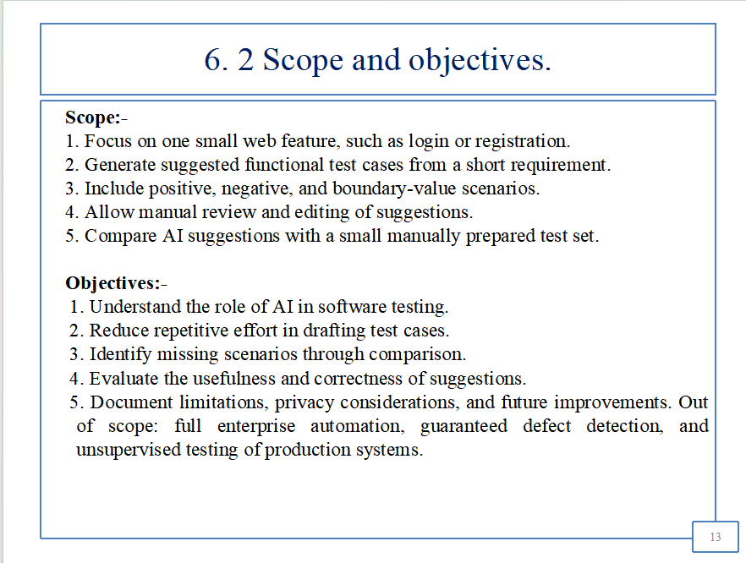
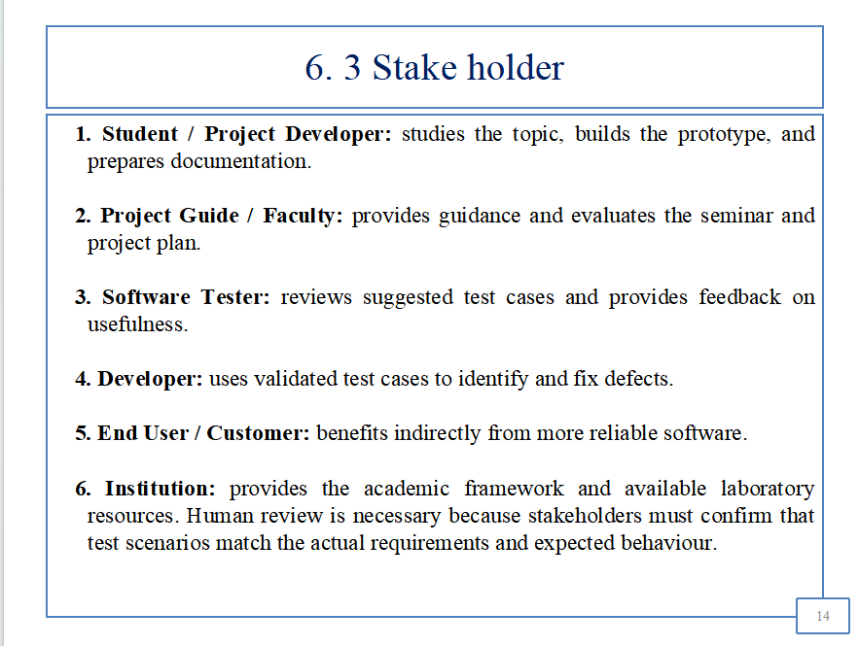

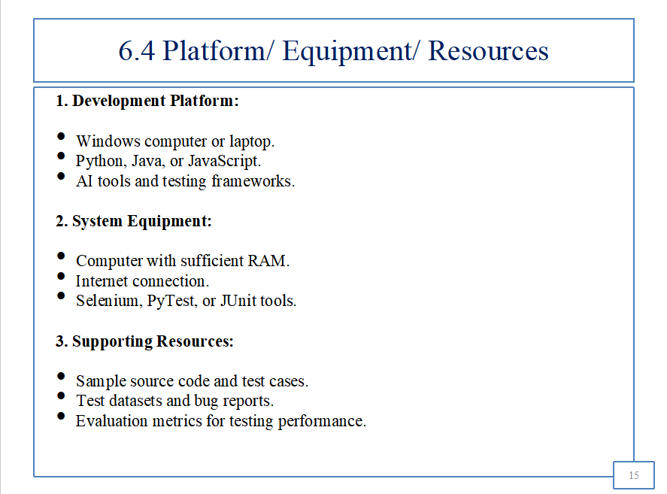
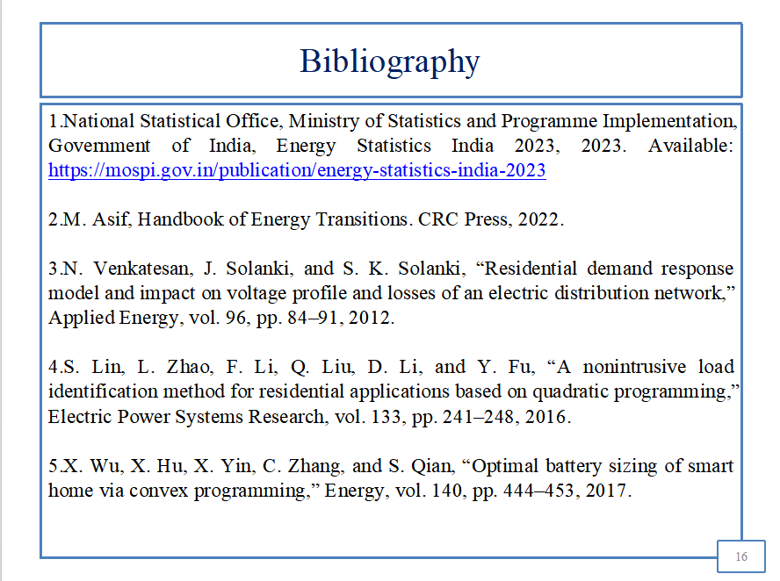

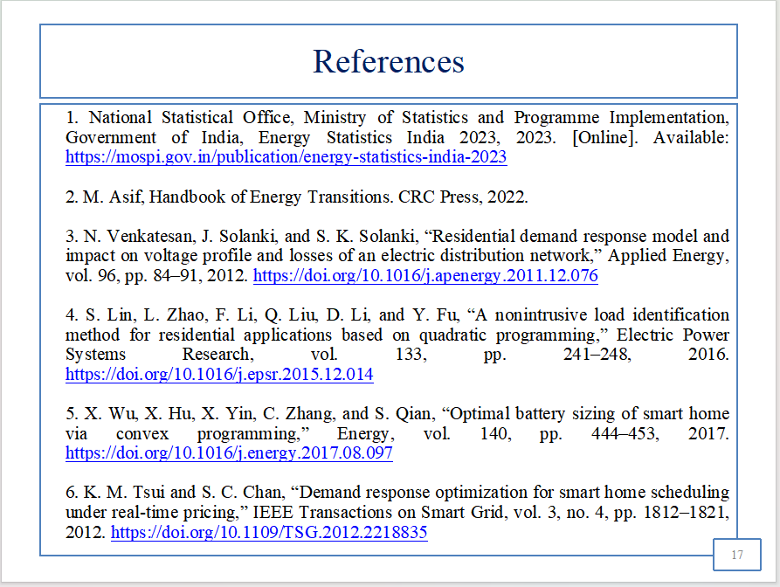

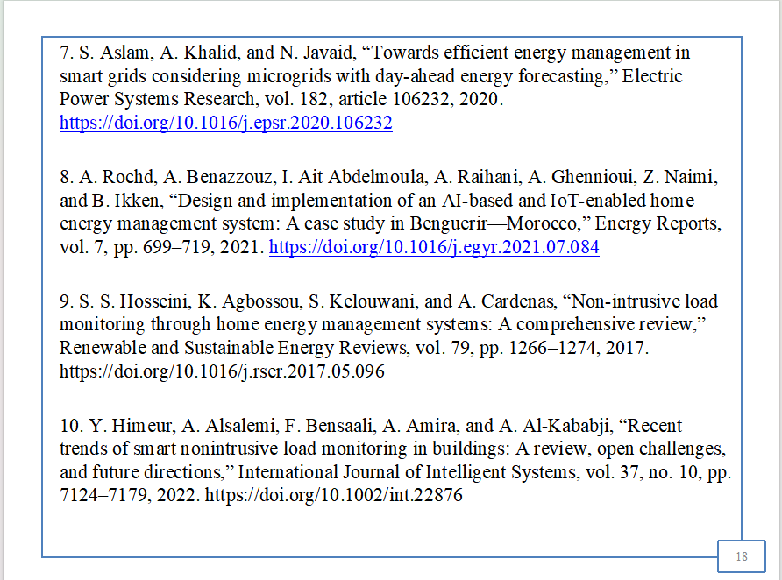



BIBLIOGRPHY
- National Statistical Office, Ministry of Statistics and Programme Implementation, Government of India, Energy Statistics India 2023, 2023. Available: https://mospi.gov.in/publication/energy-statistics-india-2023
- M. Asif, Handbook of Energy Transitions. CRC Press, 2022.
- N. Venkatesan, J. Solanki, and S. K. Solanki, “Residential demand response model and impact on voltage profile and losses of an electric distribution network,” Applied Energy, vol. 96, pp. 84–91, 2012.
- S. Lin, L. Zhao, F. Li, Q. Liu, D. Li, and Y. Fu, “A nonintrusive load identification method for residential applications based on quadratic programming,” Electric Power Systems Research, vol. 133, pp. 241–248, 2016.
- X. Wu, X. Hu, X. Yin, C. Zhang, and S. Qian, “Optimal battery sizing of smart home via convex programming,” Energy, vol. 140, pp. 444–453, 2017.
- K. M. Tsui and S. C. Chan, “Demand response optimization for smart home scheduling under real-time pricing,” IEEE Transactions on Smart Grid, vol. 3, no. 4, pp. 1812–1821, 2012.
- S. Aslam, A. Khalid, and N. Javaid, “Towards efficient energy management in smart grids considering microgrids with day-ahead energy forecasting,” Electric Power Systems Research, vol. 182, article 106232, 2020.
- A. Rochd et al., “Design and implementation of an AI-based and IoT-enabled home energy management system: A case study in Benguerir—Morocco,” Energy Reports, vol. 7, pp. 699–719, 2021.
- S. S. Hosseini, K. Agbossou, S. Kelouwani, and A. Cardenas, “Non-intrusive load monitoring through home energy management systems: A comprehensive review,” Renewable and Sustainable Energy Reviews, vol. 79, pp. 1266–1274, 2017.
- Y. Himeur et al., “Recent trends of smart nonintrusive load monitoring in buildings: A review, open challenges, and future directions,” International Journal of Intelligent Systems, vol. 37, no. 10, pp. 7124–7179, 2022.
- R. Gopinath, M. Kumar, C. P. C. Joshua, and K. Srinivas, “Energy management using non-intrusive load monitoring techniques—State-of-the-art and future research directions,” Sustainable Cities and Society, vol. 62, article 102411, 2020.
- D. Cruz-Rangel, C. Ocampo-Martinez, and J. Diaz-Rozo, “Online non-intrusive load monitoring: A review,” Energy Nexus, vol. 17, article 100348, 2025.

REFERENCE
1. National Statistical Office, Ministry of Statistics and Programme Implementation, Government of India, Energy Statistics India 2023, 2023. [Online]. Available: https://mospi.gov.in/publication/energy-statistics-india-2023
2. M. Asif, Handbook of Energy Transitions. CRC Press, 2022.
3. N. Venkatesan, J. Solanki, and S. K. Solanki, “Residential demand response model and impact on voltage profile and losses of an electric distribution network,” Applied Energy, vol. 96, pp. 84–91, 2012. https://doi.org/10.1016/j.apenergy.2011.12.076
4. S. Lin, L. Zhao, F. Li, Q. Liu, D. Li, and Y. Fu, “A nonintrusive load identification method for residential applications based on quadratic programming,” Electric Power Systems Research, vol. 133, pp. 241–248, 2016. https://doi.org/10.1016/j.epsr.2015.12.014
5. X. Wu, X. Hu, X. Yin, C. Zhang, and S. Qian, “Optimal battery sizing of smart home via convex programming,” Energy, vol. 140, pp. 444–453, 2017. https://doi.org/10.1016/j.energy.2017.08.097
6. K. M. Tsui and S. C. Chan, “Demand response optimization for smart home scheduling under real-time pricing,” IEEE Transactions on Smart Grid, vol. 3, no. 4, pp. 1812–1821, 2012. https://doi.org/10.1109/TSG.2012.2218835
7. S. Aslam, A. Khalid, and N. Javaid, “Towards efficient energy management in smart grids considering microgrids with day-ahead energy forecasting,” Electric Power Systems Research, vol. 182, article 106232, 2020. https://doi.org/10.1016/j.epsr.2020.106232
8. A. Rochd, A. Benazzouz, I. Ait Abdelmoula, A. Raihani, A. Ghennioui, Z. Naimi, and B. Ikken, “Design and implementation of an AI-based and IoT-enabled home energy management system: A case study in Benguerir—Morocco,” Energy Reports, vol. 7, pp. 699–719, 2021. https://doi.org/10.1016/j.egyr.2021.07.084
9. S. S. Hosseini, K. Agbossou, S. Kelouwani, and A. Cardenas, “Non-intrusive load monitoring through home energy management systems: A comprehensive review,” Renewable and Sustainable Energy Reviews, vol. 79, pp. 1266–1274, 2017. https://doi.org/10.1016/j.rser.2017.05.096
10. Y. Himeur, A. Alsalemi, F. Bensaali, A. Amira, and A. Al-Kababji, “Recent trends of smart nonintrusive load monitoring in buildings: A review, open challenges, and future directions,” International Journal of Intelligent Systems, vol. 37, no. 10, pp. 7124–7179, 2022. https://doi.org/10.1002/int.22876
11. R. Gopinath, M. Kumar, C. P. C. Joshua, and K. Srinivas, “Energy management using non-intrusive load monitoring techniques—State-of-the-art and future research directions,” Sustainable Cities and Society, vol. 62, article 102411, 2020. https://doi.org/10.1016/j.scs.2020.102411
12. S. Dash and N. C. Sahoo, “Electric energy disaggregation via non-intrusive load monitoring: A state-of-the-art systematic review,” Electric Power Systems Research, vol. 213, article 108673, 2022. https://doi.org/10.1016/j.epsr.2022.108673
13. “NILM Techniques for Intelligent Home Energy Management and Ambient Assisted Living: A Review,” Energies, vol. 12, no. 11, article 2203, 2019. https://doi.org/10.3390/en12112203
14. D. Cruz-Rangel, C. Ocampo-Martinez, and J. Diaz-Rozo, “Online non-intrusive load monitoring: A review,” Energy Nexus, vol. 17, article 100348, 2025. https://doi.org/10.1016/j.nexus.2024.100348
15. H. Xiang, W. Su, and Y. Zong, “Non-Intrusive Load Monitoring: A Systematic Review of Methods, Scenario-Specific Challenges, and Pathways to Practical Deployment,” Energies, vol. 19, no. 8, article 1883, 2026. https://doi.org/10.3390/en19081883
16. M. Rokonuzzaman et al., “Artificial intelligence, IoT, and solar PV-integrated home energy management systems: A review,” Results in Engineering, vol. 29, article 108954, 2026. https://doi.org/10.1016/j.rineng.2025.108954
17. “Integrating AI and IoT for Smart Home Energy Management,” IEEE, 2025. https://doi.org/10.1109/ICITR69413.2025.11353739
18. International Energy Agency, Energy Efficiency 2023. Paris, France: IEA, 2023. [Online]. Available: https://www.iea.org/reports/energy-efficiency-2023
19. International Energy Agency, Digitalisation and Energy. Paris, France: IEA, 2017. [Online]. Available: https://www.iea.org/reports/digitalisation-and-energy
20. U.S. Department of Energy, “Smart Grid,” Office of Electricity. [Online]. Available: https://www.energy.gov/oe/role-oe
21. National Institute of Standards and Technology, NIST Framework and Roadmap for Smart Grid Interoperability Standards, Release 4.0, NIST Special Publication 1108r4, 2021. https://doi.org/10.6028/NIST.SP.1108r4
22. International Energy Agency, World Energy Outlook 2023. Paris, France: IEA, 2023. [Online]. Available: https://www.iea.org/reports/world-energy-outlook-2023

SEMINAR AND PROJECT INITIATION ASSESSMENT / EVALUATION
Sr. No | Enrollment Number | Seat Number | Name of Student
1 | 24610960187 | 388507 | Nikita Pravin Choudhari
2 | 24610960204 | 388517 | Disha Badal Jugalkar
3 | 24610960219 | 388527 | Mayuri Balkrushna Mali
4 | 24610960223 | 388531 | Siddhi Vijay More

Formative Assessment
Sr. No. | Criteria | Weightage | Exam Seat Number
Sr. No. | Criteria | Weightage | 388507 | 388517 | 388527 | 388531
1 | Selection of topic / theme of seminar | 5
2 | Literature review and data presentation | 5
3 | Quality of preparation and innovativeness | 5
4 | Q-A handling | 5
5 | Time management | 5
6 | Seminar presentation report | 10
7 | Selection of theme of problem statement and its innovativeness | 5
8 | Stages of development of action plan | 5
9 | Prototyping | 5
 | Total | 50
 | Scaled to 25

Sign: ____________________
Name: ______________________________
(Course Expert/s)

